Running
an
Online
Contest

This online contest guide is specifically designed to create consistency with online speech contests in District 72. Those participating in online contests beyond the District level, or outside of District 72, should be aware that the process for the handling of logistics may differ.

This guide does not replace the Speech Contest Rulebook. In the event that anything in this guide contradicts the Speech Contest Rulebook, the rulebook must be followed.

Helen Cartmell 2020
District 72

Index

Appendix 1 - Information to help contestants look their best 8
Appendix 2 - Information for Contest Chairs to used when briefing contestants 9
Appendix 3 - Information for Chief Judge to use for judges' briefing 12
Appendix 4 - Ballots to results diagram 14
Appendix 5 - Information for Timekeepers 15
Appendix 6 - Timeline 16
Appendix 7 - Samples from a contest run sheet 19
Appendix 8 - sample portion of contest agenda 21
Contest documentation 3
Ending the contest 7
Frequently asked questions 22
Introduction 3
Official Communication from Toastmasters International 4
Personnel 3
Planning an online contest 5
Preparing Contestants 5
Preparing Judges 6
Preparing other contest officials 7
Preparing the audience 7
Running the contest 7
Toastmasters International resources 3

Introduction

Running a contest online requires more planning and preparation than a face-to-face contest. This guide provides preparation and planning ideas, as well as a timeline and documents in the Appendices, which may assist. Most of the documentation in this guide was produced for a Division Contest. It may be simplified as you see fit.

Toastmasters International resources

Toastmasters International provide some excellent resources to help you set up and run an online contest:

Best Practices for Online Speech Contests
Online Speech Contest Webinar Recording
Slideshow for online speech contests – best practices
Video Recording Guidelines for Online Speech Contests
Backgrounds for digital timekeeping
Zoom virtual backgrounds (should not be used by contestants)

Contest documentation

All contest documentation and certificates are the same as for a face-to-face contest. Everything can be downloaded in form-fillable pdf format from Toastmasters International (except for the Results form – yet to find this!). Much of this documentation can be pre-filled prior to the contest – and should be – as this speeds processes up on the day.

Another very useful document is a run sheet which details who does what, when, during the actual contest. Two samples are given in Appendix 7

Personnel

Most online contest personnel are the same as for face-to-face, with the following exceptions:

- Only one Sergeant-at-Arms is required for the Evaluation and Table Topics Contest.

- A technical support person will be needed (two is ideal) to manage Zoom functions such as:
- Any waiting room to control entry of audience
- Renaming contestants etc
- Spotlighting speakers
- Screen sharing of any PowerPoint used
- Breakout rooms (Evaluation and Table Topics Contests, and possibly for Chief Judge and Tally Counters to use)
- Recording of the Zoom call

- A project manager to co-ordinate the event. They could also be the MC during the contest.
Official Communication from Toastmasters International

Toastmasters International expect the following text to be displayed and read at the start of any online contest which is being recorded:

Read at start of conference

By attending this remote Area, Division, or District speech contest you agree to the privacy policy of Toastmasters International as well as the un-associated remote hosting service. Some of your personal information, such as name, image, and any shared messages may be shared with other meeting participants and will be recorded by Toastmasters International who may use the recording in the future as it sees fit. Your remote attendance hereby discharges Toastmasters International from all claims, demands, rights, promises, damages and liabilities arising out of or in connection with the use or distribution of said video recordings, including but not limited to any claims for invasion of privacy, appropriation of likeness or defamation.

Contest Chairs to read:
Please note that as referred to at the start of this conference this contest is being recorded. Please note it is important that, apart from those audience members who have specifically been asked to keep their videos on, we require the remaining audience to keep their videos off and sound muted at all times during the contest.

You may wish to add ‘Please do not use Chat’ as it is important that no messages of support to contestants are visible during any online contest.

NOTE: Any contestant can request not to be recorded and this request must be honoured. Contest Chairs must let tech support know of any contestant who does not wish to be recorded and recording must be stopped when they are speaking.

If any recordings are going to be published, advise everyone attending the contest.

Planning an online contest

An online contest generally requires the following (especially beyond club level):

Recruitment of:
- Contest officials: Contest Chair, Chief Judge, Tally Counters, Timekeepers, and a Sergeant-at-Arms for the Evaluation and Table Topics Contests
- Judges by the Chief Judge
- A project manager/MC
- Tech support to manage Zoom functionality

Set up of Zoom meetings for:
- The actual contest
- Contestants’ preparation (help them look their best pre-contest)
- Contestants’ Briefing
- Judges’ Briefing
- Practising Zoom functions with contestants and other contest officials (particularly for Area and Division levels) pre-contest

Download and circulation pre-contest of contest documentation (form-fillable pdfs)

Production of:
- Agenda
- PowerPoint to share during contest
- Certificates to include in PowerPoint
- Run sheet (particularly for Area and Division)

Communication decisions and set up
- Contestants, officials, tech support and MC contact details (email and phone)
(Judges contact details only circulated to other judges by Chief Judge)
- Immediate method of communication eg, Messenger groups
- Movement method for ballots and timekeeper reports (allow flexibility eg, email of a scan or photo of ballot – not everyone has the same technology)

Practice sessions for:
- Contestants
- Judges and other officials
- Tech Support

Preparing Contestants

Making the most of how they appear and sound
Some contestants will never have competed online and will probably need assistance to look and sound their best for the contest.

It is suggested that a Zoom session is held for contestants before the contest. Ask them to turn up to the meeting as if it was the contest. This will allow them to receive some advice about lighting, sound, clothing etc so they appear their best on the day! Appendix 1 can be sent out to them beforehand and used to help them prepare before the Zoom call,

At this meeting the speaking area can be determined based on the contestant with the least opportunity for movement and space. Usually, this works out to be about one metre away from their device and a metre either side of themselves for movement. Contestants with higher levels of technology cannot be advantaged by this if others do not have the same access.

Contestants’ Briefing
This can be conducted several days before the contest and is run by the Contest Chair. Appendix 2 provides guidance for the Contest Chair on preparation and delivery of this briefing.

Speaking order is determined at this event and should be emailed to the Chief Judge, Project Manager and Tech support asap – and added to any run sheet used.

Contestants’ Practice
Contestants will benefit from a practice meeting which will familiarise them with Zoom and the features they will encounter during the contest. Have the timekeepers and any Sergeant-at-Arms at this meeting, which is run by tech support, and familiarise contestants with:
- Moving in and out of breakout rooms (if being used) and meeting the Sergeant-at-Arms
- Understanding what is required of them in the breakout room for the Evaluation Contest (cannot have their notes, no phone, clearly visible to Sergeant-at-Arms etc)
- Spotlighting
- Identifying the timekeeper
- Setting themselves up before speaking.

Preparing contestants once in the contest
A naming convention is advisable for contestants to help with spotlighting and moving into any breakout room. Tech support will need to identify contestants quickly so determine a method of renaming which works for them, and advise contestants of this pre-contest.

Preparing Judges

Judges for an online contest can come from anywhere in the world if the time difference is OK with them.

Prior to the Judges’ Briefing the Chief Judge should email the Judges’ Eligibility form out and ask for it to be completed, and returned well before the contest.

The actual Judges’ Briefing can take place several days before the contest. The Chief Judge conducts this meeting and can use information in Appendix 3.

It is important judges understand the need to have their guide and ballot form as fully completed as possible, prior to the contest, to speed up the movement of ballots to tally counters and Chief Judge. Appendix 4 shows one possible method of moving ballots ready for tally counting. Tally counters and the Chief Judge could tally ballots individually and then confer, or be moved into a breakout room during the contest to complete the process.

Judges should not rename themselves in any contest, nor should they have their videos on. If a few ‘faces’ are being made visible during the contest, to help contestants feel they have a real audience, the Chief Judge can be one of these.

Preparing other contest officials

The Chief Judge usually briefs tally counters and timekeepers. This could be done via email or a separate Zoom call. It is important that timekeepers join at least one of the practice sessions for contestants.

Tally counters are advised to add contestants’ and judges’ names to their Counter’s Tally Sheet well before the contest, to speed up the calculation of results.

Information for timekeepers is in Appendix 5.

Preparing the audience

Prior to the contest, determine whether or not the audience will have their videos on or off. If too many people attend the contest, it’s best to have videos off to reduce pressure on bandwidth. Audience members can unmute and turn their videos on during any break.

Tech support may wish to set up a waiting room to hold the audience in whilst last minute checks and discussions take place amongst contest officials.

The use of chat during a contest is discouraged as people can send messages of support to some contestants which is unfair on those not receiving any.

Tech support will control the muting and unmuting of the audience.

Advise the audience of the contest protocols (eg, muted except during breaks) prior to the start of the meeting. Contest Chairs will also remind the audience during their contest introductions.

Running the contest

The run sheet samples in Appendix 7 provides a guide to the format and running of the contest, identifying what takes place when and who is responsible. At Area and Division levels a run sheet ensures everything goes smoothly.

Ending the contest

- Remember to thank everyone who has participated and made the event successful!
- Let the audience know the details of the next level of contest.
- Chief Judge to email the Notification of Contest Winners form to the Contest Chair at the next level of contest. It’s a good idea to include your Area Director and/or Division Director in this communication, so place getter details can be recorded.
- If the contest has been recorded, advise everyone of where it will be published. If anyone disagrees, they must be removed from the recording.

Appendix 1 – Information to help contestants look their best

Prepare the lighting
- Avoid fluorescent lights, and overhead lights, if possible
- Position lights behind the camera – perhaps one on the left and one on the right. This will light up your face and reduce shadows.

Camera position and use
- Your camera should be at eye level.
- If using a laptop, raise it up so your eyes are at the same level as the camera.
- When speaking, look at the camera. Avoid looking at your image on the screen.
- If standing, ensure you have set your camera up in advance and know how much area you have to move around in. Check that you can be heard if the camera is some distance away.

Sound
- The sound from devices sitting on hard surfaces can be distorted and ‘tinny’. If a blanket or other thick covering is used to cover the hard surface, sound quality improves.

Headsets
- Avoid using a headset if possible.

Background and environment
- Sit in front of a neutral background. If this is a wall, remove any distractions eg, art work/posters, if possible.
- If you sit in front of drawn curtains, make sure they are fully closed and no light creeps in. Choose neutral curtains as a background.
- Make sure there is no clutter around you – this is distracting to the viewers (and judges!).

Dress
- Dress your best! Avoid plaids, stripes and patterns. Choose solid, bold colours – and consider these in relation to the background eg, cream background and cream blouse/shirt won’t enhance your appearance!
- Avoid dangling earrings or potentially noisy jewellery
- Take care if you wear glasses as there can be glare which reflects on the lenses.
- Are you well-groomed? If not, lots of imperfections become obvious to the audience.

Prepare the family/flatmates
- Make sure the family/pets know that when you are delivering your speech you must not be interrupted, and background noise should be eliminated where possible.
- Ensure you have as much bandwidth as possible when delivering your speech. If other family members/flatmates are watching eg, Netflix, your connectivity could be affected.

Appendix 2 – Information for Contest Chairs to use when briefing contestants

Briefing preparation
- The briefing is to take place at least two days before the contest.
- Conduct the meeting via Zoom – work out a time that is suitable for all contestants.
- Email contestants the following forms well ahead of the contest date, and ask that the first two are emailed back to you well before your briefing:
  - Speaker Eligibility Form (including speech title)
  - Contestant Profile Form
  - Evaluation Contest Notes Form: speakers to print out as many sheets as they think they will need.
Note: a copy of each form is attached. The first two are form-fillable pdfs.

- Email contestants a copy of the latest Speech Contest Rulebook.

- Work out how you are going to draw for speaking order. You may want to try this method:
  - Cut strips of card (one per contestant plus one more so the final contestant has a choice as required in the Contest Rulebook), each with a different colour at the top.
  - Number each card on the back from one to X (make sure this does not show through to the front).
  - Hold cards up to the camera on your device and ask each contestant to choose a colour. Show them the number on the back and record the speaking order.

Other creative methods are acceptable but need to be transparent to contestants.

Briefing information

- Eligibility
  - All contestants must be paid up members of a club in good standing. For the International Speech Contest, they must also have completed either 6 speeches from the Competent Communication Manual OR Levels 1 and 2 from a Path.

- Speaking area
  - This should have been determined on a contest by contest basis, prior to the contest, and contestants should have practised within the parameters set.

- Speaking order
Draw for speaking order (see idea above) and once it has been determined it must be emailed to the Chief Judge to distribute to contest judges so they can prepare their ballots.

- Contest timings and lights:
  - 5, 6, 7 mins for International and Humorous, 2, 2.5, 3 mins for Evaluation Contest and 1, 1.5, 2 mins for Table Topics.

- Disqualification times:
  - International and Humorous: Less than 4.5 minutes and more than 7.5 minutes
  - Table Topics: Less than 1 minute and more than 2.5 minutes
  - Evaluation: Less than 1.5 minutes and more than 3.5 minutes

All contestants will have been shown how the lights will work – coloured backgrounds behind the timer.
- Other grounds for disqualification
  - For the Humorous and International Speeches content must be at least 75% original material. If material from others is used, it should be acknowledged as such.
  - If a speaker references something an earlier speaker says in their speech, they will be disqualified.

- Technical aspects
- Contestants need to check they can see the timekeeper as they are announced.
- They will be spotlighted by tech support when it is their turn to speak. They will be announced, and the Contest Chair will ask them to indicate when they are ready. Once this indication is given it’s over to the contestant. Timekeepers will ignore any communication taken prior to the contestant indicating they are ready.
- If there is a serious technical issue during a contestant’s speech the Chief Judge will determine what action to take.

- Judging
Judges will use the normal criteria on their ballot forms. They are instructed not to take technology or timing into account.

- Privacy
- Any contestant may decline to be recorded, if the contest is being recorded. They need to advise the Contest Chair asap so tech support can be advised.
- If, however, they decline to be recorded for the International Speech Contest at District level they forfeit the right to have a video put forward to the Regional Semi-finals if they win.

- Use of virtual backgrounds
Tempting though it may be, contestants should NOT use virtual backgrounds as these distort gestures.

- Technical problems
  - If either the signalling device OR the stopwatch fails, a contestant receives 30 seconds extra overtime before being disqualified. If either timer loses connection partway through the contest, this also means the affected contestant receives an extra 30 seconds.
  - If speakers experience technical problems when delivering their speech, and the Chief Judge feels this is hindering the judges’ ability to judge them fairly then a pause can be requested by the Chief Judge. It is the CJ’s responsibility to explain how long the contest will be paused.

- Protests
Protests on grounds of eligibility, originality or referencing another contestant’s speech can be made by contestants or judges. Contestants should contact you on your mobile or the Chief Judge on their mobile (ensure contestants have this information).

- Audience
  - The audience will be muted and video will be turned off for most people. This helps with bandwidth and ensures speakers are not interrupted. It’s not ideal but reduces a lot of interference and the possibility of technical issues.

- Contestant Interviews
  - These will be conducted by the Contest Chair immediately after the contest completion. The Chair should be prepared with extra questions in case there are delays with the start of the next contest. Please warn contestants about this.

- Presentation of participant certificates
  - These will be presented after the contest (via screen share) before contestants are interviewed.

- Presentation to winners
  - This will take place, for all contests, at the end of the entire event.
  - Place-getter certificates will be shown via screen share.

- Day of the contest
  - Contestants should arrive in the Zoom room 30 minutes before the contest start time, regardless of when their contest is, so that any technical issues can be ironed out early. They do not need to stay in the Zoom call after this if their contest is later in the day.
  - They may need to schedule more time than usual for ‘their’ contest as there are several logistical processes taking place behind the scenes with judges and ballots etc. The next contest cannot begin until all judges are back in the Zoom room and ready to go and this may take longer than in a physical contest.
  - Contestants may have a technical check when they are called into the Zoom room immediately prior to speaking. They should advise they want to do this as they start. Once they are happy with the set up and audio, they announce ‘Ready’. Timing will start once they give their first verbal or non-verbal cue to the audience, in the normal way, at the start of their actual speech.

During the contest, keep contestants’ contact details close by. If someone hasn’t appeared in the contest, you will need to phone them.

Appendix 3 – Information for Chief Judge to use for judges’ briefing

- Normal briefing information
- Much of the judges’ briefing will focus on judging criteria and how it is to be applied, requirement to pick a winner, ignore timings, must place 3 contestants, no ties, protests etc.

In addition, the following needs to be covered to address the issues arising from the use of a different medium:

- Speaking Area
- Prior to the contest the Chief Judge will be advised of the speaking area (per contest). This will have been determined earlier with contestants and is based on the range/space available to the contestant with the least flexibility. Once this has been determined, all contestants will be required to perform within the same speaking area.

- Chief Judge to explain the limitations of the area to judges and advise them not to take it into account if someone steps outside. However, judges may, using criteria on their ballot forms, feel that someone continually misused the area to the detriment of their speech, and may want to mark them accordingly.

- Technology
- Explain to judges that technology used by contestants will differ and not everyone will have the same set up. Technology limitations should not be taken into consideration when judging.

- Judges’ Guide and Ballot
- These should have been emailed to judges as form-fillable pdfs before the Judges’ Briefing

- Only the criteria on this form should be used when judging.

- Chief Judge to explain how to fill ballot in and emphasise it’s important to have as much filled in as possible beforehand. Contestants’ speaking order will be available before the day of the contest so names can be added well in advance.

- A digital signature can be used at the bottom of the ballot form.

- Suggest taking a screen shot of the form and cropping the bottom portion only for sending (if the top part of the form has been used). If top part of the form is not used eg, judge writes on hard copy, then the whole sheet can be sent to the tally counters. Alternatively, consider taking a photo of the bottom part to send to tally counters.

- Forms are to be sent to all tally counters and the Chief Judge; Chief Judge to ensure judges have contact details (emails and phone numbers) for these people.

- Signing in to the contest
- Judges to keep their own names in an online contest and should SWITCH OFF their video so they remain completely anonymous in their role.

- Protests
- If any judge wishes to protest, they should contact the Chief Judge as soon as possible by the chosen method of communication eg, phone (separate from Zoom!).

- Technical issues during contest
- The Chief Judge has the ability to pause the contest if there are technical issues such as:
  - Something which hinders a judge’s ability to judge a contestant (apart from a minor issue)
  - Contestant obviously having issues with technology
  - Large number of audience members unable to hear.

- If there are issues for judges, they must contact the Chief Judge asap using messaging system chosen.

- Chief Judge needs to explain how the contest will be paused and for how long.

- Contact methods
- Provide judges with emails and phone numbers of the tally counters and of Chief Judge.
- Set up an alternative messaging system which everyone is comfortable with eg, text or Messenger to be used if needed. Ensure judges have these contact details pre-saved in their email systems/in their Contacts on phones etc.

- After the contest
- Judges must delete any contest documentation saved during the contest, once it has finished.

Appendix 4 – Ballots to results diagram

Judges
Email Judges’ Official Ballots asap AND
text results to Chief Judge

Chief Judge
- Check Tally Counter Sheets
- Check timings for disqualifications
- Refer to Tiebreaker ballot if needed
- Liaise with Tally Counters by phone or in breakout room
- Complete Results Form
- Complete Notification of Contests Winners form – email to Contest Chair of next contest level
- Email Results Form to Contest Chair and MC or Tech Support for placegetter cert. production.
Contest Chair
Announces results at end of all contests (or when determined)
Tally Counter 2
Complete Tally Counter Sheet and email to Chief Judge

Tally Counter 1
Complete Tally Counter Sheet and email to Chief Judge
Tiebreaker Judge
Complete Tally Counter Sheet and email to Chief Judge

Timers
Complete Time Record Sheet and email to Chief Judge

Appendix 5 – Information for timekeepers

- Change your name to ‘Timekeeper’ in Zoom
- Ensure you know how to change the virtual background in Zoom to show the timekeeper slides green, orange and red. These are downloadable from TI at: https://www.toastmasters.org/resources/news-and-announcements/online-meetings

Timing procedure from TI – slightly different to a physical contest

- Timer One uses a stopwatch (or other timing device) to time each speaker and is considered the official timekeeper. They record speech times on the Timing Record Sheet. This is a form-fillable pdf.

- Timer Two uses a stopwatch (or other timing device) to time each speech in order to operate the signalling device.

- If either the signalling device OR the stopwatch fails, this means the contestant receives 30 seconds extra overtime before being disqualified. If either timer loses connection partway through the contest, this also means the affected contestant receives an extra 30 seconds.

Communication if timers not in the same location

If you are in a different location to the other Timekeeper, you will need a way of communicating. This could be via Messenger or WhatsApp, or even phone.

In addition, Timer One will need to be able to scan and email the Timekeeper’s Record Sheet to the Chief Judge, immediately after the final speaker. A photo could also be taken and emailed or sent via Messenger or WhatsApp – whatever works best for you and the Chief Judge.

Appendix 6 - Timeline

The timelines below are a guide only. A two to three-week preparation window is recommended.

Task | Responsibility | When | Notes
Appoint Tech Support | Project Manager | 3 weeks prior | Two people ideally needed for a large event with slide show, breakout rooms etc.
Appoint Chief Judge | Project Manager | 3 weeks pre-contest
Appoint Contest Chair(s) | Project Manager | 3 weeks pre-contest
Appoint judges | Chief Judge | 3 weeks pre-contest | Judges can be appointed from anywhere in the world for a virtual contest. Check their eligibility in the Speech Contest Rulebook.  At Division and District levels make sure they are not in any contestant’s club.
Appoint Timekeepers (2), Tally Counters (2 plus), Sergeant-at-Arms (1) | Project Manager | 2 weeks prior
Prepare spreadsheet of all contest officials’, contestants’ and tech support staff contact details (emails and phone numbers) | Project Manager | 2 weeks prior | Liaise with Contest Chair to get all contestants’ details.
Distribute contact details’ spreadsheet to all officials and tech support staff, including Chief Judge | Project Manager | 2 weeks prior
Email copies of Judge’s Eligibility form, Guide and Ballot form(s) and Speech Contest Rulebook to Chief Judge – with instructions to email out to all judges. | Project Manager / Chief Judge | 2 weeks prior | Judges should only be known to the Chief Judge.
Email copy of Speech Contestant Eligibility form and Speech Contest Rulebook to Contest Chair(s) with instructions to email out to contestants | Project Manager / Contest Chair | 2 weeks prior
Schedule and circulate Zoom meeting links:  - contest  - contestant preparation (appearance)  - contestants’ briefing  - judges’ briefing  - contest preparation (familiarisation with Zoom for contestants, timers, sergeant-at-arms and tech support | Tech Support / Project Manager | 2 weeks prior | Some of these meetings may be able to be scheduled using a basic (not paid) Zoom account by those running them, if they prefer. Eg, the Contest Chair may be happy to organise the contestants’ briefing (which is unlikely to go over 40 mins) using their own basic Zoom account
Prepare contest agenda | Project Manager | 2 weeks prior | Keep agenda simple (see Appendix
Circulate contest Zoom link and agenda to potential audience, eg Area Directors to email out to clubs in their Area | Project Manager | 2 weeks prior | For a Division or District Contest advertise in the monthly D72 newsletter and on Facebook to reach a wider audience.
Set up a Messenger or WhatsApp group of contest officials including tech support and Chief Judge | Tech Support | 2 weeks prior | A quick method of communicating with all officials is really useful during the contest. Chat in Zoom should not be used for contest-related conversations.
Hold Zoom meeting to help contestants look their best online | Contest Chair, Tech Support, Project Manager | 10 days prior | Guide each contestant in the set up of their devices, their clothing and space entitlement so they can appear their very best on the day.
Hold Zoom meeting to help contestants familiarise themselves with Zoom functions and meet timers | Contest Chair, Tech Support, Project Manager | 6-10 days prior | Timers and Sergeant-at-Arms (Eval and TT contest) are to attend so contestants meet them. At this meeting include moving people to and from breakout rooms, spotlighting, management of contestants by Sergeant-at-Arms in breakout rooms.
Prepare contestant participation certificates and upload to PowerPoint  Prepare placegetter cerificates ready to add names | Project Manager | 5 days prior | Participant certificates can be presented in any order.
Hold Zoom Contestants’ briefing | Contest Chair | 3-4 days prior | Similar to a face-to-face briefing: cover eligibility, timings, disqualifications, protests and selection of speaking order.
Email candidate speaking order to Chief Judge, tech support and Project Manager | Contest Chair | Immediately after contestant briefing
Email speaking order to judges for their guide and ballot form | Chief Judge
Email tally counter forms completed with contestants’ and judges’ names to tally counters | Chief Judge | After contestant briefing
Email contestant names to time keepers | Chief Judge | Once received from Contest Chair
Hold Judges’ briefing | Chief Judge | 3-4 days prior | Include time keepers and tally counters
Add contestant speaking order slide to PowerPoint | Project Manager | Once received from Contest Chair
Finalise any run sheet used and circulate to officials and tech support | Project Manager | 3-4 days prior
Check in with Contest Chairs and Chief Judge – is everything in place? | Project Manager | Day before
Check PowerPoint finalised and accessible to tech support | Project Manager | Day before

Appendix 7 – Samples for a contest run sheet
Sample 1
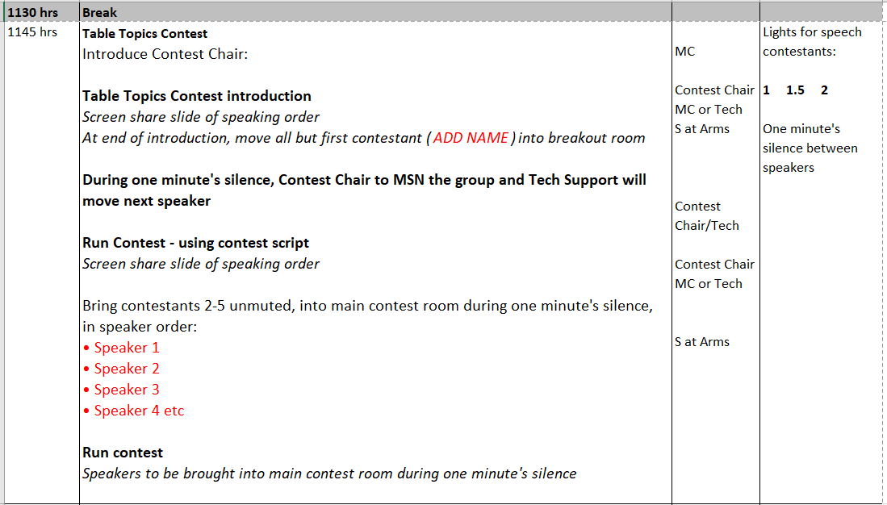

Sample 2
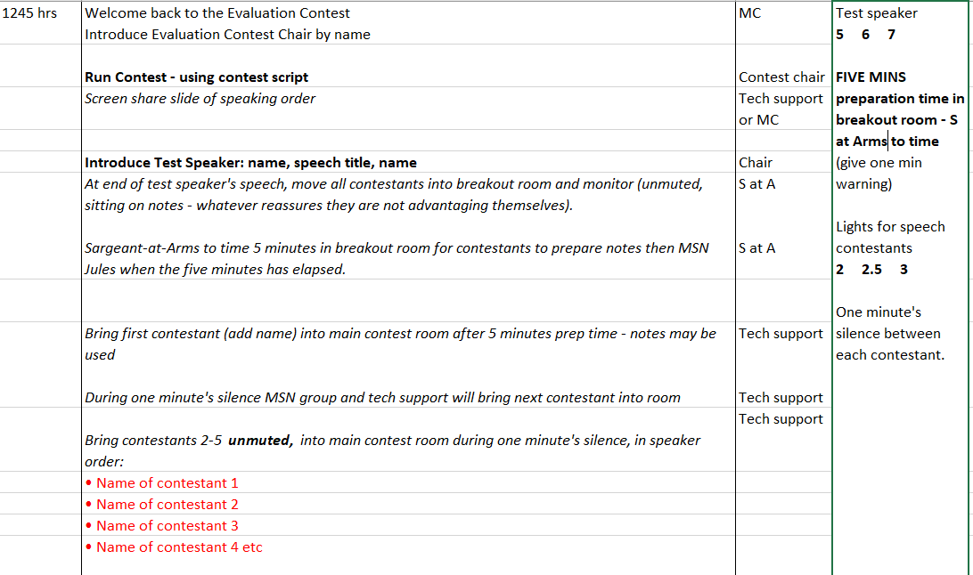

Appendix 8 – Sample portion of a contest agenda

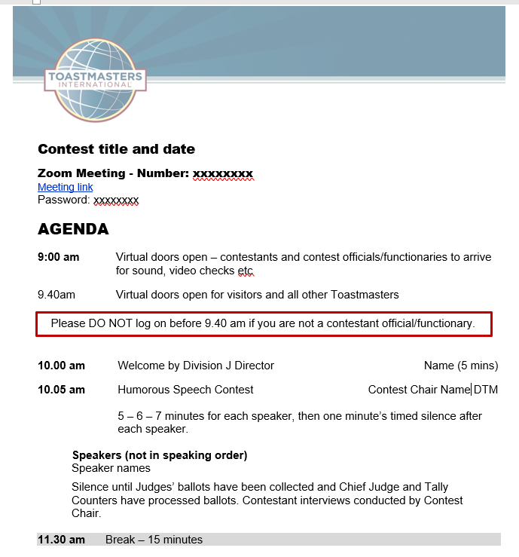
Frequently asked questions

- Evaluation contest candidates have five minutes to write notes in the breakout room. How can they be managed after this when they should not have access to their notes etc?

To some degree, this relies on the integrity of contestants. Audio and video must be on all the time in the breakout room so that any potential contact eg, via phone, can be monitored. Contestants should be advised not to have phones in the room with them. The Sergeant-at-Arms, who is in the room with them, should be able to see most of a contestant’s body, and especially their hands, at all times and be sure they are not looking at their notes until it is their turn to speak. It is difficult to cover all eventualities, especially with smart technology, so contestants who use a smart watch or other device which can connect with the outside world might be asked to leave these outside the room they are in. Whilst some mitigations can be put in place to reduce possible cheating, there has to be reliance on people’s honesty.

- Contestants feed off reactions from the audience. How is this managed in an online contest? Can the audience have their audio on so contestants can hear laughter etc?

If members of the audience are unmuted, any sound made eg, baby crying, background conversation, is picked up and amplified and, heard by contestants. It can be very distracting and could disadvantage some. Some of the contest officials may have their video on so that they appear at the top of a contestant’s screen and provide some faces to ‘speak to’. Sometimes contestants print out faces and stick these behind their camera so they have something to look at when speaking. Others have had family members in the room, behind the camera, acting as a live audience. None of the solutions are ideal but unwanted noise interrupting a contestant when speaking, is probably something none of them want.

- To make it a level playing field do all the contestants stand up to speak or do they all sit down, or can they choose?

The only expectation in an online contest is that every contestant has the same size speaking area. This is determined pre-contest, and it is based on the distance available to the contestant who has the least sophisticated technology. If they can only stand a metre away from their microphone before losing sound quality then that is the distance for all in that contest. Judges are not to take technological limitations into account when judging.

Contestants can sit or stand. For some, the nature of their speech and their use of video may mean sitting is a better option. For others who want to use more body language, standing would be their choice. They only have to keep within the pre-determined speaking area.

