Area Director Club Visits and Reports Made Easy

Club visits are an enjoyable part of the Area Director’s' responsibilities. The reports you create are useful for you, your future successor, and the district leadership. You can see trends and understand how each club performs and what kind of help they might need.

Most importantly, it is your opportunity to encourage club members in your area, motivate them to progress as speakers and leaders, and inject enthusiasm for Toastmasters. The motto of Toastmasters NZ is an excellent focus for a motivational address:
FIND YOUR VOICE – BOOST YOUR CONFIDENCE,

How to plan a club visit

- Email the President and VP Ed and suggest visit dates.
- Check out the last AD report (ask the previous AD for copies of their club reports).
- Print out the area visit form https://www.toastmasters.org/resources/area-directors-club-visit-report-1471
- It's a good idea to offer a speech as part of your visit. Smaller clubs may be grateful and it's a way for you to inspire the club. Clarify this with the VP Ed and/or the President.
- Ask for a slot of 3-5 mins at the end of the meeting to give feedback to the club. This is an excellent opportunity to praise the club for what it does well and carefully point out any aspects of the club culture that need adjusting. You could also mention the Distinguished Club Programme and urge the club to use it to set goals. Your verbal feedback is vital as your written report will only be read by the club President, whereas your verbal feedback will reach all members at the meeting.

During the club visit

During the meeting, fill out the form you printed out as much as you can. Talk to people and be friendly and approachable. If the Toastmaster asks for volunteers for Table Topics, jump up and do it! Talk to experienced members, as well as to new people. Your main task is to encourage, encourage, encourage!

Use your evaluation skills in your report.

While it's important to be encouraging, ensure that you also mention negative aspects. Use the CRC structure and brace any criticism with positive aspects.

Here are examples of my First Impressions of two different clubs:

First Impressions no. 1:

Westport Toastmasters is a small but outstanding club. A key word that club officers use to describe the culture of their club is 'team'. And indeed, there is a true sense of teamwork between members. Visitors are warmly welcomed and invited into the 'team'. Although the club is currently small (with only nine members), the meeting was run text-book style, using the Toastmasters meeting protocol. This led to an excellent meeting with strong leadership by the TM of the day, good speeches, and clear and supportive feedback. This club is to be congratulated!

First Impressions no. 2:

The club has a rather self-contained vibe. As a guest, I was greeted with the words: "What are you doing here?" and people largely ignored me until the second half when the Toastmaster of the day introduced me. Apart from that, the meeting had lots of energy, and it was great to see that the club has grown in the last six months since my last visit. The designated Toastmaster of the day was suddenly away sick, and I was impressed by the President taking up the reigns and doing well as a Toastmaster at short notice.

How to find whether educational goals have been met

A tricky part of creating your report is to find all the information to fill out page 4, where you need to insert names and individual goals. Here is how to find the relevant information.

Go to Toastmasters.org > Leadership Central > District Central > Distinguished Performance Report/ Daily Reports/ Educational Achievements

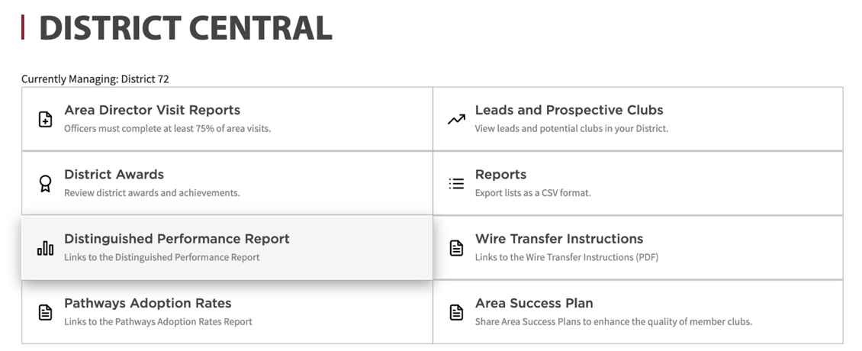

Click on Daily Reports
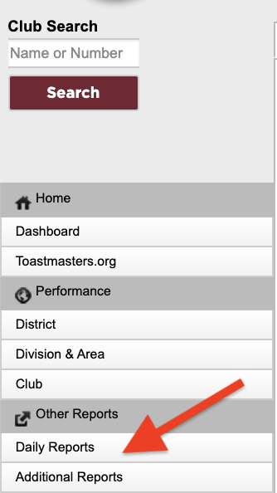

Go to Educational Achievements (Current year)
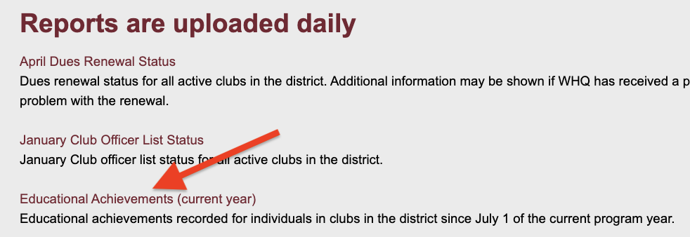

In this report, you can see exactly who has completed each level in every club in the District. This is what it looks like:

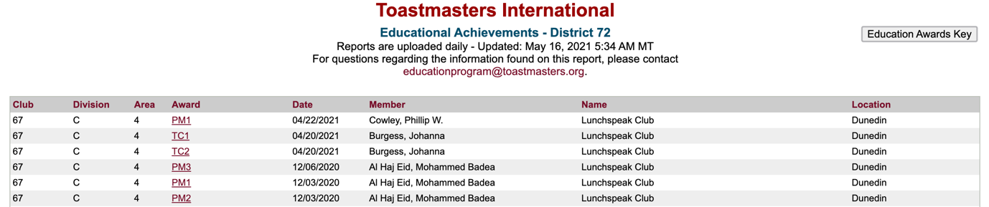

You can also find the educational achievements by looking at the Area Membership Report. Here is where you can find it:
Toastmasters.org >Leadership Central >District Central >Reports

Tip: Download both reports (the Area Membership Report and the Area Club Officer Report) twice a year.

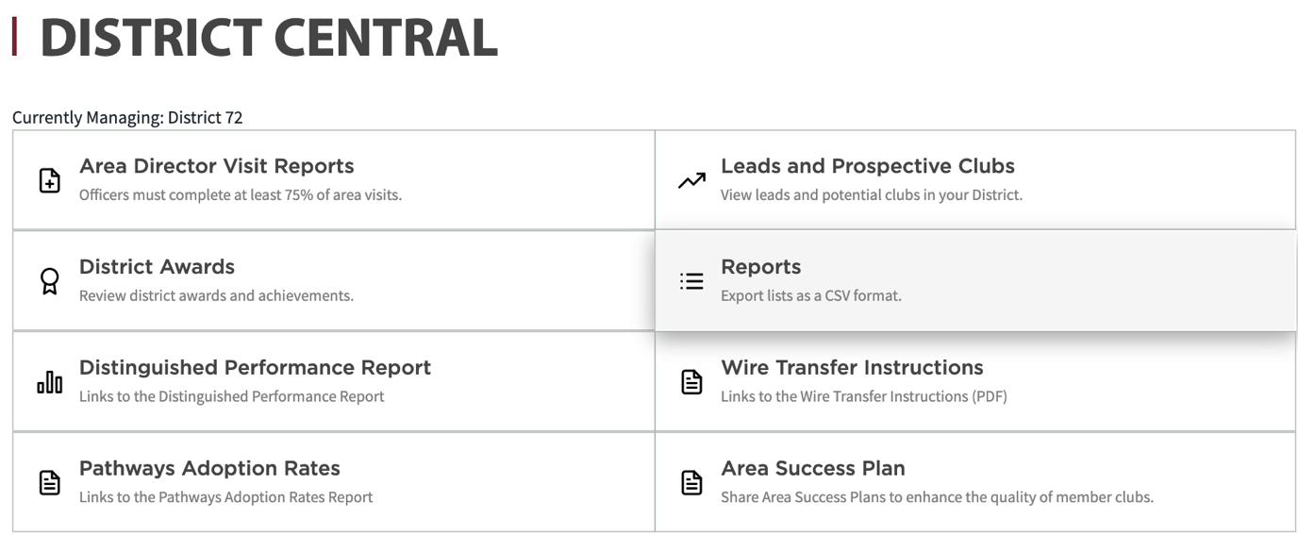

Download the Area Membership Report. You can find the educational achievements of every member in your area (grouped into clubs). The educational awards are in a column on the right-hand side.

Choose the clubs in your area and fill in the information on page 4 of your Area Director's Visit online form.

How to find whether club growth goals have been met

To find this information go to:
Toastmasters.org >District Central >Distinguish Performance Report >Performance >Club

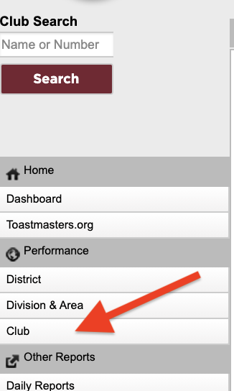

You can immediately see how the clubs in your club perform and can fill in the information on page 4 focused on membership. For example, the club shown below added four members but did not add additional four members to gain an extra point in the DCP (Distinguished Club Programme).

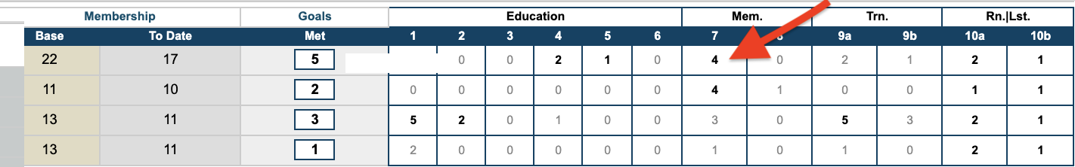

Submitting your report to TMI

Go to District Central on TMI and click on Area Director Reports. Start filling in the form according to your notes.

TIP: After every few questions, save your report!

You will need to fill in every response to a question. For example, when you get to the last page, if there is nobody who has completed Pathways Level 5, you need to write Nobody or put in a full stop and then set a target date. If you don't fill out everything, TMI doesn't allow you to submit.

TIP: If there is something you can’t answer, just put a full stop as a ‘response.’

After you press the button Submit, you will find out whether you have filled in everything correctly. If not, go back to fill in the areas indicated in red to be able to submit your report.

Keeping a record of your Area Reports

Soon after you submit your report, TMI will send you an email. Please scroll down to find your report, copy it, and save it in a designated folder. This folder then becomes a resource both for you going forward, as well as for your successor.

Mary Jaksch,
Division Director E (elect)

